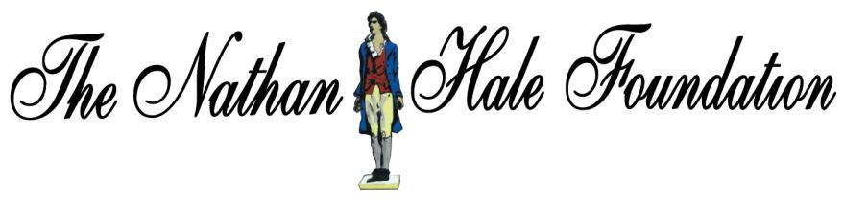

Troops in Transit
Program
Passenger Rules and Regulations
Christopher C. Hart
03//07/2016

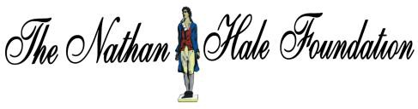
Please sign and date.

Passenger Rules and Regulations for the Troops in Transit Program
The following Rules and Regulations have been established by Christopher C. Hart, President and Founder of the Nathan Hale Veterans Outreach Centers (NHVOC). Said Rules and Regulations cover all vehicles owned and/or operated by the Nathan Hale Veterans Outreach Centers including vans, wheelchair accessible vehicles, busses and cars.

- The NHVOC driver is not to lift or attend medically any passenger.
- The NHVOC driver is only permitted to stop the vehicle for emergencies and to pick up and discharge passengers.
- Passengers should not request the drivers to make side trips to conduct personal business.
- Passengers are not permitted to smoke, chew tobacco, drink alcohol. Use foul language or bring weapons, drugs or any other illegal substance into the vehicle.
- The NHVOC driver may not provide transportation to any veteran who is intoxicated, abusive or poses a threat to the driver or other passengers in the vehicle.
- Passengers should not engage in any activity that would distract the driver’s attention.
- Passengers should wear seat belts at all times. Any passenger refusing to buckle-up will be denied transportation.
- All trash must be taken by the passenger and disposed of when dropped off.
- The Passengers must be ready at pick up and departure times.
- It is Passengers and/or care takers responsibility to contact NHVOC as soon as possible regarding appointment cancelations or changes.
- If the driver deems a passenger to ill for transport the driver may request a note from a VA physician stating such passenger is safe for transport. Any alternate transportation must be set up by passengers’ family or care taker.
- Passengers utilizing the NHVOC Troops in Transit Program will not be eligible to receive reimbursement for travel expenses.

By signing below the passenger agrees to all above stated Rules and Regulations and waves the NHVOC of any responsibility regarding liability and personal injury while using said services.

I hereby authorize any and all persons and agencies to release any and all information necessary for eligibility for transportation to the NHVOC office. All information obtained will be kept confidential and will be used only in connection with evaluating transportation needs.
Passenger

Signature Date

Family Member/Care Taker
Signature Date

Keep for your records.

Passenger Rules and Regulations for the Troops in Transit Program
The following Rules and Regulations have been established by Christopher C. Hart, President and Founder of the Nathan Hale Veterans Outreach Centers (NHVOC). Said Rules and Regulations cover all vehicles owned and/or operated by the Nathan Hale Veterans Outreach Centers including vans, wheelchair accessible vehicles, busses and cars.

- The NHVOC driver is not to lift or attend medically any passenger.
- The NHVOC driver is only permitted to stop the vehicle for emergencies and to pick up and discharge passengers.
- Passengers should not request the drivers to make side trips to conduct personal business.
- Passengers are not permitted to smoke, chew tobacco, drink alcohol. Use foul language or bring weapons, drugs or any other illegal substance into the vehicle.
- The NHVOC driver may not provide transportation to any veteran who is intoxicated, abusive or poses a threat to the driver or other passengers in the vehicle.
- Passengers should not engage in any activity that would distract the driver’s attention.
- Passengers should wear seat belts at all times. Any passenger refusing to buckle-up will be denied transportation.
- All trash must be taken by the passenger and disposed of when dropped off.
- The Passengers must be ready at pick up and departure times.
- It is Passengers and/or care takers responsibility to contact NHVOC as soon as possible regarding appointment cancelations or changes.
- If the driver deems a passenger to ill for transport the driver may request a note from a VA physician stating such passenger is safe for transport. Any alternate transportation must be set up by passengers’ family or care taker.
- Passengers utilizing the NHVOC Troops in Transit Program will not be eligible to receive reimbursement for travel expenses.

By signing below the passenger agrees to all above stated Rules and Regulations and waves the NHVOC of any responsibility regarding liability and personal injury while using said services.

I hereby authorize any and all persons and agencies to release any and all information necessary for eligibility for transportation to the NHVOC office. All information obtained will be kept confidential and will be used only in connection with evaluating transportation needs.
Passenger

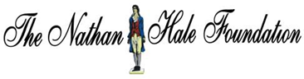

THE NATHAN HALE WELLNESS CENTER-FOOD PANTRY POLICIES

• All veterans and their immediate families are welcome to our food centers

• All veterans and families may visit the pantries once a week

• The pantries are free choice, please take only what you need.

• Selling or gaining profit from items of The Nathan Hale Food Pantry will result in a termination of the participants’ food pantry privileges.

CLOTHING OUTLET

• All veterans and families are welcome to take what they need for free.

• Any items taken may not be used for resale

